"STD 101 in a Box" -
Ready-to-Use Presentations
User's Guide
June 9, 2014

1600 Clifton Rd.
Atlanta, GA 30333
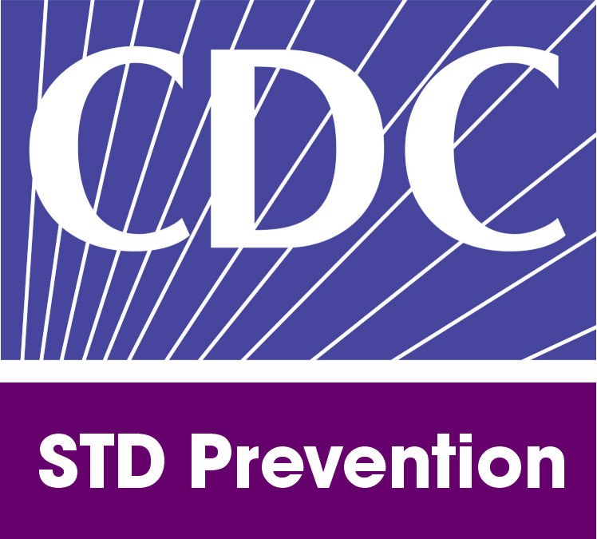U.S.A

"STD 101 in a Box" - Ready-to-Use Presentations User's Guide

Table of Contents

I. STD 101 in a Box Description 2
II. STD 101 in a Box Materials 2
III. Target Audiences 3
IV. Customization 4
V. Suggested Agendas 6

STD 101 in a Box Description

"STD 101 in a Box” - Ready-to-Use Presentations is based on materials from a pre-conference workshop, STD 101, which has been presented as a preconference workshop at the National STD Prevention Conferences since 2002. The purpose of the workshop is to provide conference participants, who may have had little or no STD prevention experience, a basic knowledge of STD Prevention so that they could actively participate in the conference. The purpose of “STD 101 in a Box” is to provide users with the conference materials so that they may develop similar workshops.

These materials may be customized for conferences or group discussions and presentations. Topics include STD clinical and behavioral information, HIV/STD inter-relationship, STD epidemiology, and STD prevention program information.

Potential users may include, but are not limited to, community-based organizations, public health departments, schools of public health, health educators, primary care providers, and Disease Intervention Specialists (DIS).

STD 101 in a Box Materials

"STD 101 in a Box" materials include PowerPoint presentations, Adobe Acrobat and MS Word documents, and a short demonstration video of the "Sex in the City" activity.

Presentations (available in PowerPoint and Adobe Acrobat)
- Welcome presentation
- STD 101 for clinicians
- Current epidemiology of selected STDs
- The STD/HIV inter-relationship
  - The STD/HIV inter-relationship support document
- Expanding opportunities for STD prevention
- State and local STD prevention programs

Exercise and Instructional video (available in QuickTime, Shockwave, or Windows Projector)
- "Sex in the City, An Inside View" instructional document
- "Sex in the City, An Inside View " demonstration video for the "Sex in the City" activity

Support materials (available in MS Word and Adobe Acrobat)
- "STD 101 in a Box" user's guide
- Discussion questions
- Evaluation form (sample)

Target Audiences

The "STD 101 in a Box" - Ready-to-Use Presentations materials provide eight presentations. Although the presentations are informative, they may not be appropriate for every audience type. Table 1 suggests appropriate audience types for each presentation.
Table 1: Target audience(s) for each presentation
 | Target Audience
Presentation | General | Medical providers | CBOs | Health Departments | Schools of Public Health | Schools of Medicine/ Nursing | Adolescents and Youths
Welcome presentation | X | X | X | X | X | X | X
Common STDs: STD 101 for clinicians | X | X |  | X |  | X
The STD/HIV inter-relationship | X | X | X | X | X | X | X
Expanding opportunities for STD prevention |  | X | X | X | X | X
Current epidemiology of selected STDs | X | X | X | X | X | X | X
State and local STD prevention programs | X |  | X |  | X | X

Customization

These materials may be adapted to meet your needs. All materials provided are in the public domain. You may reproduce these materials without permission. You are also free to adapt and revise these materials; however, you must remove the Department Health and Human Services (HHS) and Centers for Disease Control and Prevention (CDC) name and logo if changes are made.

If you plan to customize the presentations, you may download the files in Microsoft PowerPoint format (.pptx), and text documents in Microsoft Word (.docx). Because some of the files are large, you may experience significant download time.

There are several ways in which the presentations may be customized. In general, one may include specific examples of state or local data, or both, interventions, issues, or policies. Table 2 details how each presentation may be customized.

Table 2: Tailoring of STD 101 in a Box presentations to target the audience
Presentation | Customization
Welcome presentation | - Use an audience-specific agenda (refer section V)  - Modify the objectives to meet the needs of the audience
Common STDs: STD 101 for clinicians | - Discuss case studies specific to your audience and jurisdiction  - Exchange the clinic image for local images  - Discuss the implementation of CDC STD/HIV treatment guidelines in local practice on treatment therapies and clinical trials (status reports)
The STD/HIV inter-relationship | - Discuss specific local examples of the effect that STD and HIV morbidity has on your community
Expanding opportunities for STD prevention | - Discuss case studies of expanded opportunities for STD prevention in your jurisdiction
Current epidemiology of selected STDs | - Describe the local epidemiology of selected STDs, including local disease in MSM, women, youth, and children
State and local STD prevention programs: | - Describe the function and purpose of your state and local STD prevention programs

The "STD 101 in a Box" - Ready-to-Use Presentations website provides links to additional resources that may be used to tailor your presentations to a particular audience.

The Welcome Presentation lists the objectives. Table 3 links the curriculum material(s) with corresponding curriculum objectives.

Table 3: Materials and corresponding objectives
Objectives | Material(s)
- Describe the signs, symptoms, and complications of common STDs | - Common STDs: STD 101 for clinicians and non-clinicians
- Describe the connection between STDs and other public health problems | - STD/HIV inter-relationship  - "Sex in the City, an Inside View" activity
- Describe expanded opportunities for STD prevention | - Expanding opportunities for STD prevention
- Identify populations in the U.S. with high and increasing STD morbidity | - Current epidemiology of selected STDS
- Describe the function and purpose of state and local STD prevention programs | - State and local STD prevention programs

Suggested Agendas
These materials may be used separately or as a group depending on the user's intentions. The following examples identify audience specific agendas.

Mixed Audience Agenda
- Introductions and welcome
- STD 101
- The STD/HIV Inter-relationship
- “Sex in the City, An Inside View” activity
- Expanding opportunities for STD prevention
- Current epidemiology of selected STDs
- State and local STD prevention programs
- Conclusion and evaluation

Clinic or Primary Care Providers Agenda
- Introductions and welcome
- STD 101
- The STD/HIV Inter-relationship
- Expanding opportunities for STD prevention
- Current epidemiology of selected STDs
- Conclusion and evaluation

Health Department Agenda
- Introductions and welcome
- STD 101
- The STD/HIV Inter-relationship
- Expanding opportunities for STD prevention
- Current epidemiology of selected STDs
- Conclusion and evaluation

School of Public Health Agenda
- Introductions and welcome
- STD 101
- The STD/HIV Inter-relationship
- “Sex in the City, An Inside View” activity
- Expanding opportunities for STD prevention
- Current epidemiology of selected STDs
- State and local STD prevention programs
- Conclusion and evaluation

Medical/Nursing School Agenda
- Introductions and welcome
- “Sex in the City, An Inside View” activity
- The STD/HIV inter-relationship
- Expanding opportunities for STD prevention
- STD 101
- State and local STD prevention programs
- Current epidemiology of selected STDs
- Conclusion and evaluation

Young Adults Agenda
- Introductions and welcome
- “Sex in the City, An Inside View” activity
- Common STDs
- Current epidemiology of selected STDs
- Conclusion and evaluation

