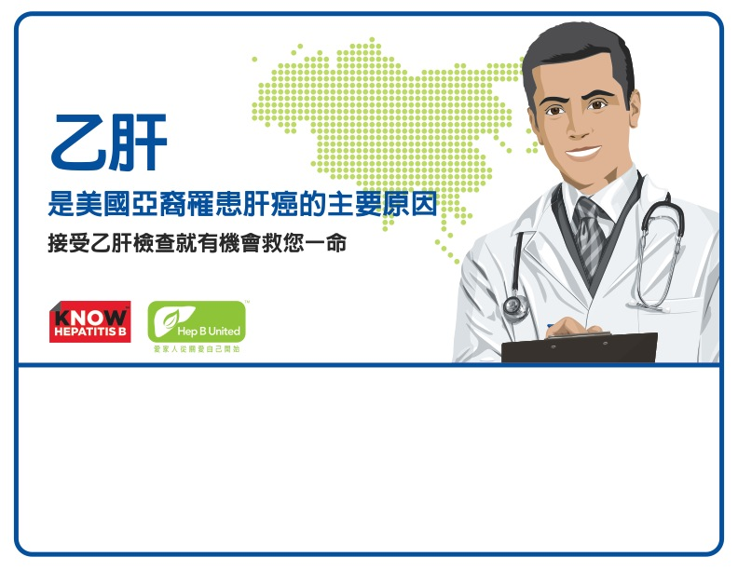
Sunday, May 19, 2014 | 10AM – 3PM
Sponsoring Organization Name
100 Main Street, | City, State
Call (000) 999-9999 for more information

