http://www.sustainable19125.org  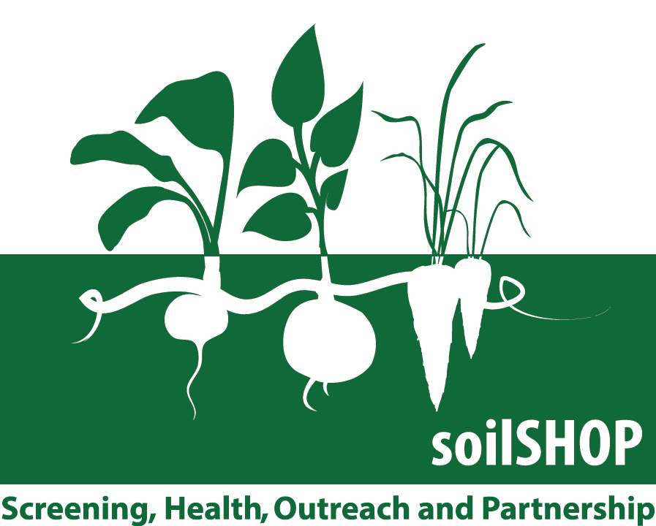  Your Soil Sample Number:  Your Soil Screening Result | Your Soil Sample Number:  Your Soil Screening Result
Your Soil Sample Number:  Your Soil Screening Result | Your Soil Sample Number:  Your Soil Screening Result

Thank you for coming!

DISCLAIMER: This soilSHOP is a health education event where community members are offered free lead screenings to raise awareness of potential lead in their soil sample, and about how to avoid exposure to lead while gardening or playing in yards. The screening method will provide participants with same-day screening levels, but cannot provide information about source(s) of lead in soils. Participants may wish to seek further laboratory testing to confirm their lead screening result. soilSHOP staff will help explain soil screening results and share information on ways to reduce potential exposures to lead in soils.

Thank you for coming!

DISCLAIMER: This soilSHOP is a health education event where community members are offered free lead screenings to raise awareness of potential lead in their soil sample, and about how to avoid exposure to lead while gardening or playing in yards. The screening method will provide participants with same-day screening levels, but cannot provide information about source(s) of lead in soils. Participants may wish to seek further laboratory testing to confirm their lead screening result. soilSHOP staff will help explain soil screening results and share information on ways to reduce potential exposures to lead in soils.

Thank you for coming!

DISCLAIMER: This soilSHOP is a health education event where community members are offered free lead screenings to raise awareness of potential lead in their soil sample, and about how to avoid exposure to lead while gardening or playing in yards. The screening method will provide participants with same-day screening levels, but cannot provide information about source(s) of lead in soils. Participants may wish to seek further laboratory testing to confirm their lead screening result. soilSHOP staff will help explain soil screening results and share information on ways to reduce potential exposures to lead in soils.

Thank you for coming!

DISCLAIMER: This soilSHOP is a health education event where community members are offered free lead screenings to raise awareness of potential lead in their soil sample, and about how to avoid exposure to lead while gardening or playing in yards. The screening method will provide participants with same-day screening levels, but cannot provide information about source(s) of lead in soils. Participants may wish to seek further laboratory testing to confirm their lead screening result. soilSHOP staff will help explain soil screening results and share information on ways to reduce potential exposures to lead in soils.

